Eli(se) Davidson
A. Hostetter
Memory & Trauma
May 06, 2024

Revisit the Representations of Memory, Trauma, and Madness.
Because your name is not your own. How could I remove myself from [our] minds?
But I do not want to speak of me any longer,
so then read the World.

Read of the Power [you have] known and all the ways it will touch too many. You are enmeshed, but do not overstep into centrality, because the ‘adult society’ is not generous.
(06/24/2022 | 04/25/2024) Overturn each history. Turn away from the World. Read.

Monday, February 7th 2022 It is good. No more breakdowns, end the cycle, and reflect …Monday February 6th 2023 Do I learn to heal, to cope, to tolerate, only so I can relapse into my poor state of decay …Sunday, July 3rd 2023 [ ] said some real nice things about my skill and “it” factor while shit-faced. I am taking it to heart …Thursday, October 26th 2023 This is of occupation. This is of domination. How dirty – It’s hard to reflect on self with innocent life …Tuesday, January 30th 2024 A being of my own making in a twenty-year-olds body.

February 3rd, 2023: Davidson, Eli(se), ‘I Remember, I Remember’
I remember a hug that shattered the soul of the 10-year-old that is trapped by the shelter of my aged skin and I wish I could feel the intoxication of intolerable pain just once more.

April 3rd 2023: Davidson, Eli(se), (Creation) April Entry iv.
you ask whether this gold cage is really a home,
but no one gives an ear, so you eat
another feather than see it fall because
the marble floor is so close and too far
and you can’t bear to test the lock beyond
that initial mordant click.

to want more is to ask less, so you eat
another feather because your mouth feels like
a graveyard where words wither on your tongue.

Speak. Speak. Speak.

you await in silence, in cold and bare
glimmers of gold will strike you, mayhap
the Sun aligns and for an instance you will fly,
fly for a home, but nothing more because
you are full of yourself.

October 23rd 2023: Free-write on Kurt Vonnegut’s Cat’s Cradle
I believe it is deeper than that. I wasn’t quite able to articulate exactly what I had wished for, but [R] had my back and I had his. It is really encouraging to have classmates …

January 23rd 2024: Judith Lewis Herman, Trauma and Recovery pp.55 (notes)
to break it down: “seasoning”
- disempowerment and disconnection
- instilling terror and helplessness
- destroying sense of in relation to others
- threats against others
- "omnipotent" power
- assault on autonomy/physical being/psychological self
- a source of fear and humiliation, but also of solace
☆ hunger strike as the ultimate resistance to maintaining a sense of autonomy

February 14th 2024: Ocean Vuong, On Earth We’re Briefly Gorgeous pp.157-179 (notes)
tender [veal] & children – “I thought my saying it would help me believe it”
- societal [hermeneutics of] suspicion and sustainability
related: ‘the meat’ from HN THUR0201

February 22nd 2024: Vanessa Springora, Consent pp… (notes)
“No one liked me…As adolescence laid its awkward hands on me, I felt it only as an all-consuming solitude” – [p]age 23
“All these beautiful people…One day I too was going to write books” – [p]age 15

March 19th 2024: Professor Feedback on Essay Proposal
These thoughts are very disparate.

March 21st 2024: Reading Response to Ovid’s Ars Amatoria
One more; from a journal article in the Hudson Review called "Love in Ovid and Lucretius" mentions that "in citing laws of nature to prove that love is really sexuality, Ovid and Lucretius anticipate much in Freud. And possibly Freud had them in mind when he said: "The most striking distinction between the erotic life of antiquity and our own no doubt lies in the fact that the ancients laid the stress upon the instinct itself whereas we emphasize its object" (537). How much of this play of objectification, naturalized objectification of Women, remains in Ovid's writing, as compared to Homer or Hesiod or Semonides, etc.?

April 30th 2024: Davidson, Eli(se) – EN290 Final Paper, footnote
¹The usage of “Vietnam War” versus “American War” signifies the naming-processes in which [we] locate the recall of the Wars’ stories, whether it be individual or collective. My usage of this noun is to align with Tim O’Brien’s interpretations of the War, as he depicts his later-in-life ‘return’ to Vietnam with his daughter, stating that “the place was at peace”(173), emphasizing the political and moral mythifications attached to the creative imagination of home/land in memory.
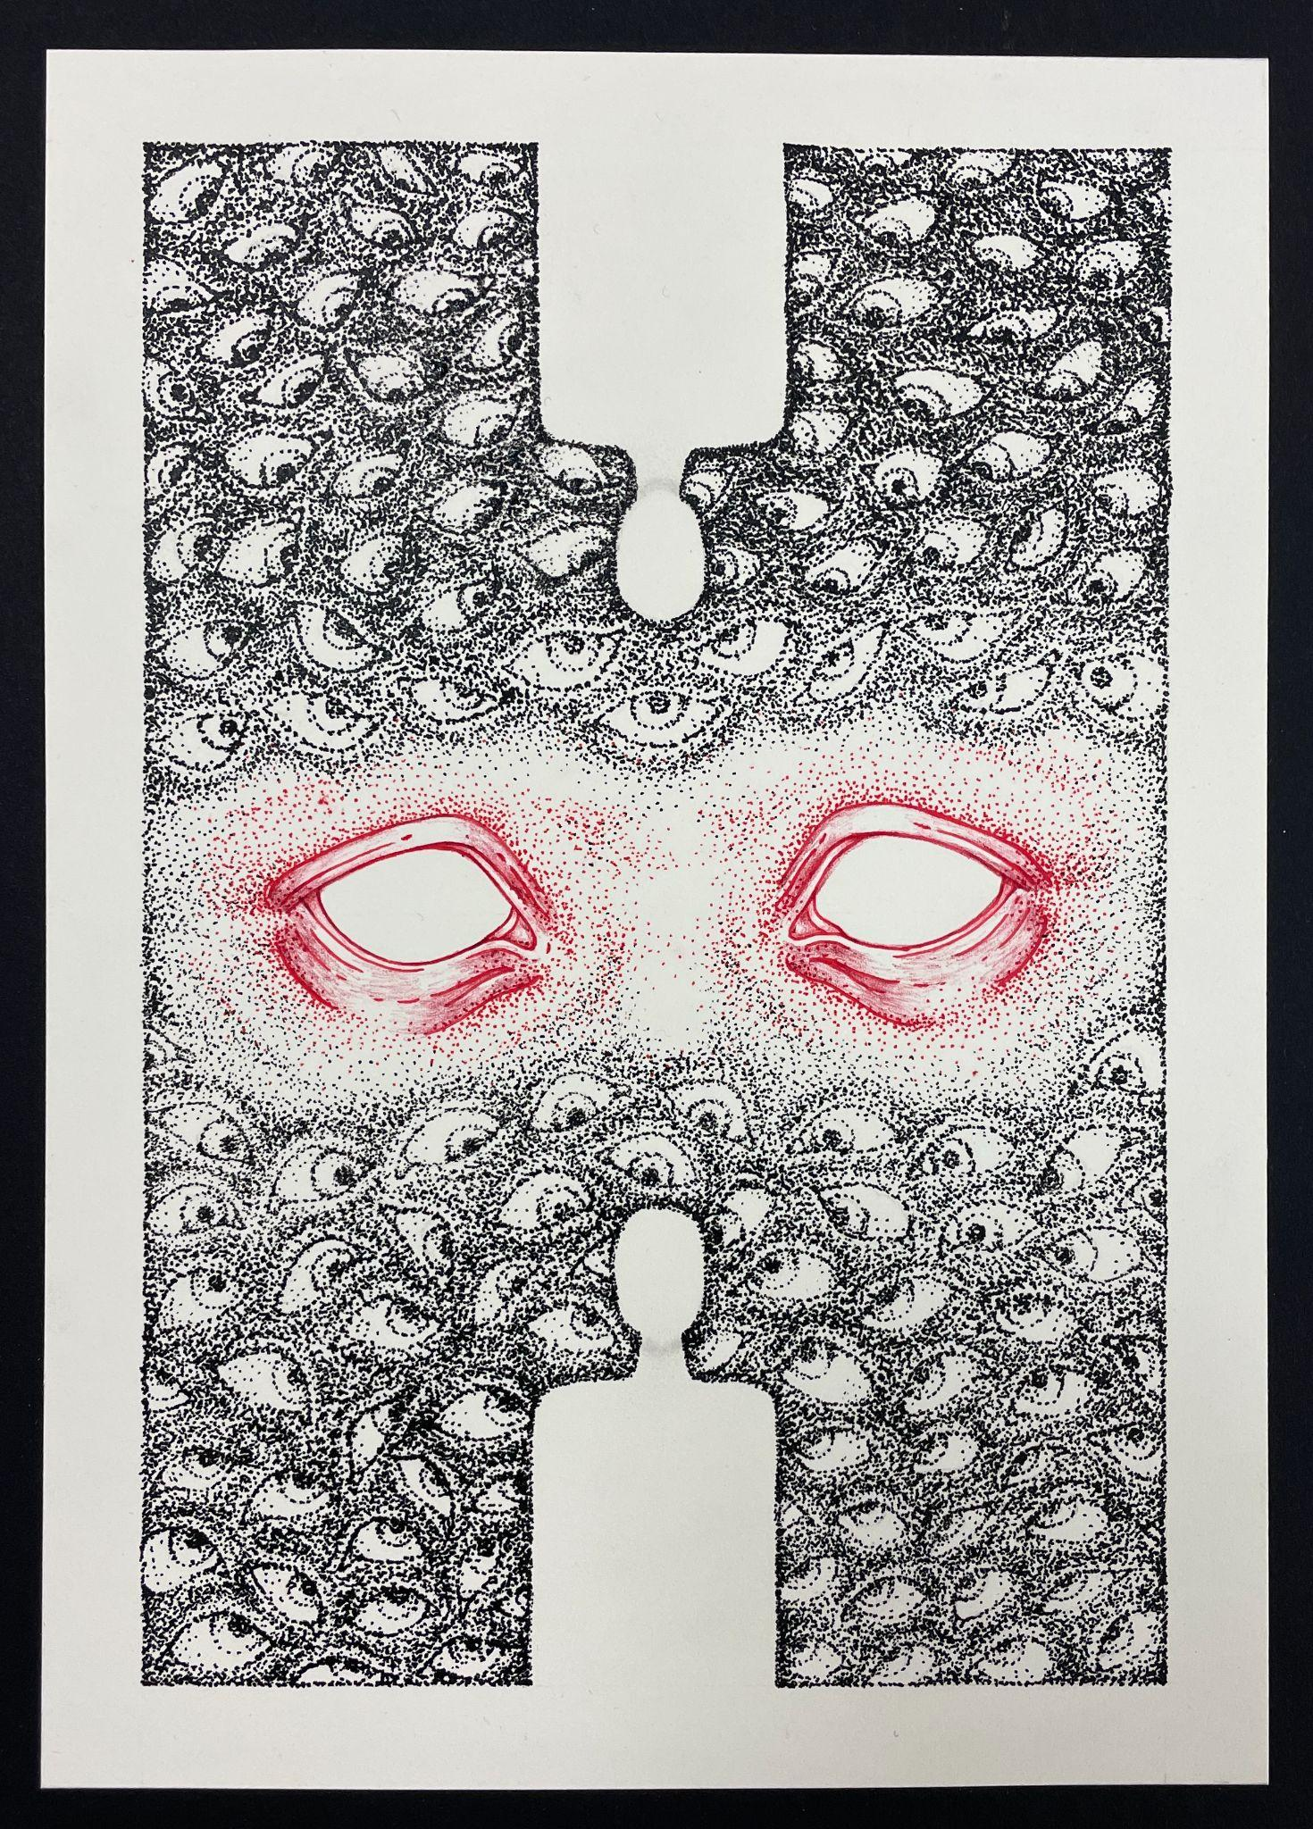
And so [we] continue on. I believe that there is an overwhelming amount of prosperity found when the fragmentation of [our] pains is expressed. Self-indulgent, maybe. But nonetheless, if I am to view the modalities of optimism, then I will place them upon a linear access and uncover the myths of living; my age brings about more words to wither, and I am attempting to listen with open ears and wide eyes. Tell me another story, for I will approach with arms aghast and mind un-meditated. Maybe I will remember, or maybe I will doubt my own markings of memory: fragmented, but is my name not my own?
“Split under Observation”
Ink. May 2022

